Jason De Leon

00305640

Centos upgrades

How to SSH into linux:

In order to remote into Linux, you will need to SSH in. Please collect your IP address for the Linux server and do the following command.

Command: (ssh “serveruser@Ipaddress”)

For it was: ssh [jason@192.168.1.215](mailto:jason@192.168.1.215)

If it’s the first sign on you will be asked if you want to continue. Just type “yes” and then hit enter.

Afterwards it will ask for the password to complete the login.

This is for the repolist of my CentOs server:

Command:

(sudo yum repolist)

This will allow you to update the server.

The command goes as follows: (sudo yum update)

This will ask for your approval so all you have to do is type “Y” and hit enter.

Please note that this takes a considerable amount of time to complete.

PPA install:

***(sudo yum-config-manger ppa:mozillateam/firefox-next repository)***



Firebox install:

***(wget -O-*** [***https://download.mozilla.org/?product=firefox-latest-ssl&os=linux64&lang=en-US***](https://download.mozilla.org/?product=firefox-latest-ssl&os=linux64&lang=en-US) ***)***



The following is how to install Tmux:

Command is (sudo yum install tmux)

Please note that the command will ask for you approval to finish the install. Just do “Y” and enter to continue.

To lunch Tmux just type tmux in the command line.



Then to leave Tmux you must do the following in order.

Ctrl + B, followed by X

Then it’ll ask you to confirm that you want to quit. Hit “Y”



The following is meant to install emacs.

Command is: (sudo yum install emacs)

Please note that this will also ask for an approval like the previous one and this takes a long time to install.

Similar to Tmux you have to just type “emacs” on the command line to run it.



It looks like this when you’ve started the program:

To exit you have to do “Ctrl + x Ctrl + c”

Here we will need to install fail2ban, but here are a few things we need to do before installing it.

I was going through costant erros and needed to do some research and it appears we need to install a prior service or application and here is the command for it.

(sudo yum –enablerepo=extras install epel-release)

Once you’ve installed it you should be allowed to install fail2ban without any issues. In order to do that we must type the following:

(sudo yum install fail2ban)

Please note that the installer will ask for permissions on two separate occasions. Just type “Y” and enter to continue.

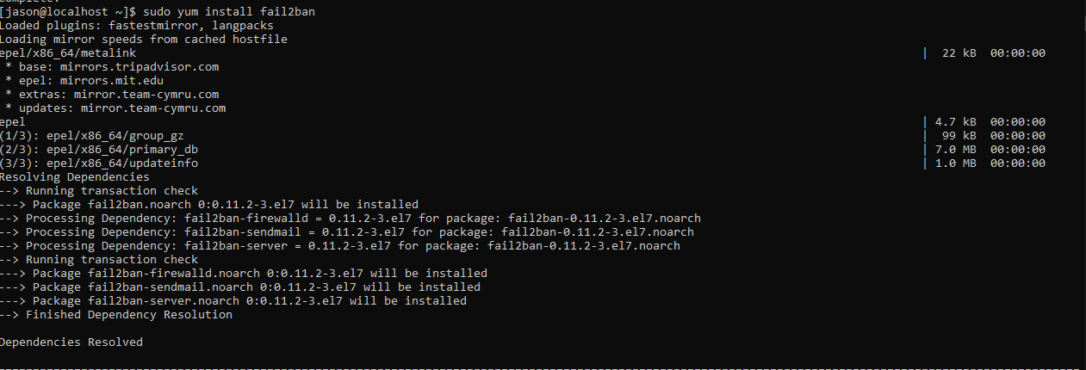

To check if the program is installed just try and go to it’s directory. The following command will help you get there: (cd /etc/fail2ban)



If you plan on modifying the files it’s heavily recommended that you make a .local copy of fail2ban.conf and jail.conf.

Do vi fail2ban.local and vi jail.local.

Picture bellow are what you find in those files. Please note that I haven’t made any changes.

To quite it’s ctrl c to stop insert mode and then :wq to save and quit. To simply quite just do :q

Now we will be installing Cowsay.

The command to do so is:

(sudo yum install cowsay)

Please note that it will ask for permissions. Type Y and enter and possibly before that it may ask for your login information.

To run Cowsay just type : (cowsay -e @@{whatever you want}), you know you’ve done it correctly when you see a cow saying what you wanted.

Similar to fail2ban we will have to install a few things before getting the ability to install lolcat.

We will need to install snapd the command goes as following: (sudo yum install snapd)

Please note, in order to install snapd you will need to have the following done.

(sudo yum –enablerepo=extras install epel-release)

If you already done this for fail2ban then you won’t need to do it again.

Once snapd has been install you’ll need to another similar step as before. We will need to do the following:

(sudo systemctl enable --now snapd.socket)



Note:

Please give the system to push out the last change we made. If you don’t wait you will get an error



Finally, we should be able to install lolcat.

The command goes as follows.

(sudo snap install lolcat)

You’ve successfully installed lolcat and want to use it.

If you type (lolcat -h) it will give you all the commands and how to use it on a file.

